**Project Name**: House Price Prediction

**Group Number**: 8

**Participants**:

| Participant Name | Email | Roles |
| --- | --- | --- |
| Anjan Shrestha | anjanshrestha@my.unt.edu | Design application, train Machine Learning model, and validate the prediction |
| Naresh Balla | NareshBalla@my.unt.edu | Make improvement in the model by using different AI techniques and write project report |
| Bhargav Ram Pushadapu | BhargavRamPushadapu@my.unt.edu | Build and test client-side application including integration to API (website) |
| Byanagari Rohith | byanagarirohith@my.unt.edu | Perform exploratory data analysis on the dataset to know more about the dataset |
| Balaji Mandava | BalajiMandava@my.unt.edu | Build server-side application (API) and perform data preprocessing |

**Project Workflow:**

We've created a WhatsApp group for this project's teamwork in order to improve communication. In order to improve collaboration, we set up a github project to store all of our code in one location. Additionally, we have scheduled a zoom meeting among team members for each milestone to assess our progress and address any roadblocks. For tracking tasks, we have used Trello software and a production project plan template in google sheet.. Each team member will participate in research, planning, design, model implementation, training, validation, testing, and monitoring so that everyone in the team will have the knowledge necessary to create an effective model right away

| Github Link | <https://github.com/anjanshrestha123/house-price-prediction> |
| --- | --- |
| Dataset | <https://www.zillow.com/research/data/> |
| Production Project Plan | <https://docs.google.com/spreadsheets/d/1KnotKDuMn6CdcOR6lmuMMhLGPv7c7GKttz6CBhznAGM/edit#gid=1853352180> |
| Trello Link | <https://trello.com/b/u6CPAwjF/project-1> |

**Project Abstract:**

A home is sometimes the most significant and expensive purchase a person makes in his or her lifetime. It is critical that homeowners have a reliable mechanism to monitor their assets and it would be nice if people can predict their future home’s price before buying it so that they can make an informed decision. The first time buyers have difficulty most of the time deciding what they need to look into while buying their future home and what factors affect the cost of a home. It would be easy to fall into the hands of the greedy real-estate agents and spend more money than they actually needed to buy a house.

It would be really helpful to the average home buyer if there’s a system to see the prices of the houses in a particular area of his/her interest. Having the ability to see the prices in a particular area will help the end-user make a better decision about the purchasing decision he/she’s about to make. Moreover, house price prediction is helpful not only to the potential buyers, it will be helpful for house owners who want to assess the current value of their property. Using the data they can refinance, sell or take loans based on the property.

In this project we will implement machine learning and artificial intelligence methods to assess the current value of the property based on historical data. We will train, test and validate the results and create a portal where the user can enter a zip code of his choice and the date. The data user entered will be passed to the machine learning model by using APIs and the output will be displayed for him which will contain the average price of the house in that zip code he/she started with.

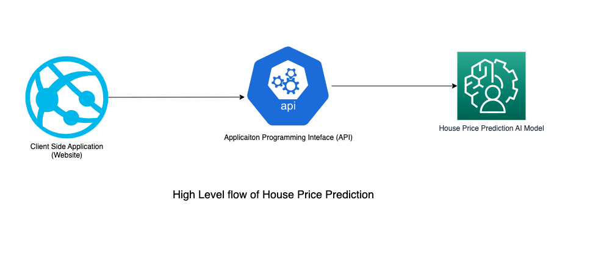

**Project Design and Milestones:**

In this project, we will be building three different applications to build a house price prediction software. Those are explained below:

1. Client-Side Application (Website):

The first application is client-side where users can interact and provide their input such as zip code and date for which they want to see their house price. We will be using Visual Studio Code as an IDE and different front-end technologies such as HTML, CSS, Material Design, Javascript, Angular, and so on. It is responsible for getting input from the users, sending it to the server-side application, and displaying the response in the webpage.

1. Server-Side Application (API):

The second application is server-side API which basically runs in the backend and accepts the input request from client-side application, passes data to trained Machine Learning model, and returns the predicted response to the webpage. Pycharm will be used as an IDE and various backend technologies will be used such as Python, Json, and so on.

1. Machine Learning Model:

The third application is Machine Learning Model which utilizes data from Zillow, preprocesses it, plots different graphs for visualization, trains and tests the model using AI algorithm, and predicts the house price using the trained model. We will be using Google Colaboratory and Jupyter Notebook as an IDE and using Python programming language with different libraries such as numpy, pandas, sklearn, matplotlib and so on.

This project will be divided into three main milestones that are described below:

| Milestone | Date | Incremental Feature |
| --- | --- | --- |
| 1 | February 30th, 2023 | Complete building all three applications i.e. client-side, server-side and machine learning model |
| 2 | March 6th, 2023 | Perform validation and make improvements |
| 3 | March 7th, 2023 | Complete project report |

**Resources and Related Projects:**

1. The least transparent sector of our economy is real estate. Every day, housing prices change and are occasionally inflated rather than based on appraisal. The house pricing models operate on the data sets that are utilized in the suggested model are explained in these studies using machine learning.

Reference links: <https://www.ijraset.com/research-paper/house-price-prediction-using-ml>

1. To predict the sale prices, linear regression algorithms ordinal least square ride regression algorithm is used. It can be concluded that which model is best suitable for the given case by evaluating each of them using the evaluation metrics Reference links: <https://medium.com/codex/house-price-prediction-with-machine-learning-in-python-cf9df744f7ff>